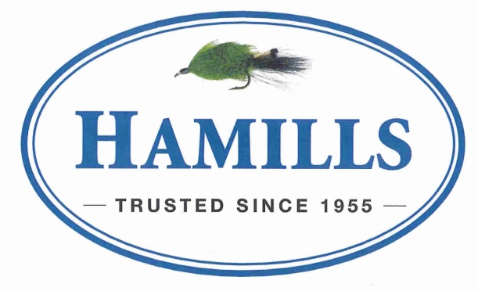
Area: | All Rotorua Lakes & Rivers (excluding Lake Aniwhenua)
Eligibility: | MMSFC members, day members or financial members of a club affiliated to NZSFC
Entry: | $25 per adult, $12 per junior (includes Fish n Game fee) | Licenses available from  Hamills, 137 Cameron Road, Tauranga  All anglers must have a current region license and adhere to the rules thereon.  We must have your licence number  No licence number = no fish weighed!  MINIMUM LENGTH – 450mm
 | Non-members $10 for day membership plus entry fee
Entries close: | 7pm Thursday 23rd November 2023
Fishing Time: | Start – 12 noon Friday 24th November 2023  Stop – 3pm Sunday 26th November 2023
Prizes: | 1st to 3rd heaviest – Boat section
 | 1st to 3rd heaviest – Land based section
 | 1st to 3rd Junior section
 | Best Condition factor
 | Worst Condition factor
 | Overall average weight
 | 10 x Lucky Fish Draws
 | Heaviest Fish weighed at Saturday’s weigh in
 | ONE PRIZE PER FISH
 | PRIZES ARE VOUCHERS
Weigh in: | Saturday – 12pm to 1pm at Otaramarae Boat Ramp. BBQ Sausage Sizzle on offer.  Sunday – 4pm to 5pm at Mt Sport Fishing Club (MOSC Clubrooms, Salisbury Ave)  4 TROUT PER PERSON PER WEIGH IN
Prizegiving: | Sunday 6:30pm at MOSC
Convenors: | Dean Tirana 0211089179 or Ross Lucas 0272830523
 | All skippers are responsible for the safety of their vessel and crew at all times during the tournament

 | Name | Trout  Licence # |  | Club | Member  No. | Day Member  $10 |  | Junior  $12 | Adult  $25 | Paid
1
2
3
4
5
6
Team Captain: |  |  |  |  |  |  |  |  | Total:
Phone: |  |  | Boat Name: |  |  |  | Call Sign:

